Fully Automatic Tomo-statics Software Package

----AutoModel

User’s Manual

PanImaging Software Development Ltd.

May, 2016

Index

0. AutoModel Introduction 1

1. AutoModel installation 3

1.1 Create directory 3

1.2 Copy AutoModel files 3

1.3 Install driver of AutoModel 3

2. Running AutoModel in batch mode 5

2.1 Starting AutoModel 5

2.2 Define the header file 5

2.3 Define the LMO parameter file 6

2.4 Batch mode process 7

2.5 Batch mode process results 8

3. Running AutoModel step by step 11

3.1 Generating LMO data 11

3.2 First arrivals picking 11

3.3 Coordinate transformation 12

3.4 First arrivals display and edit 12

3.5 Initial velocity model building 13

3.6 First arrival tomography inversion 14

3.7 First arrival tomography inversion QC 15

3.8 Extend the velocity model laterally 17

3.9 Define high velocity interface 18

3.10 Calculate datum statics 18

3.11 Calculate first arrival residual statics 19

3.12 Static correction quality control 20

3.13 Statics Output 21

3.14 Display multi-line velocity 21

3.15 Display multi-line statics 22

1. AutoModel Introduction

AutoModel is a FULLY AUTOMATIC 2D tomo-static software package, it contains following functions,

*---Automatic seismic data loading,*

*--- Automatic first arrival picking,*

*--- Automatic travel time edit,*

*--- Automatic building initial velocity model,*

*--- Automatic first arrival tomography inversion,*

*--- Automatic high velocity interface defining,*

*--- Automatic datum statics calculation,*

*--- Automatic first arrival residual statics estimation,*

*--- Automatic QC and evaluation,*

*--- Automatic tomo-static report generating,*

Suppose you have more than 100 2D lines, provide the file name of each line to AutoModel in the afternoon, and you can get the results of first arrivals, velocity models, statics and processing report for all the lines when you come back the next morning!

AutoModel can run fully automatic or interactively step by step.

There several special technologies that ensure the success of AutoModel.

--- Powerful automatic first arrival picking, AutoModel will do S/N ratio and will ignore those bad traces.

--- The tomography inversion result does is independent to the initial velocity model.

--- It does analysis and evaluation about the whole process, including first arrival picking quality and inversion reliability, and give PASS/FAIL judgment for each line.

There are 3 limitations in AutoModel, the maximum number of shots is 500, the smallest lateral and vertical grid size are 10 and 5 separately.

AutoModel is a function simplification of ToModel, for any further request or more powerful processing ability, please contact PanImaging Ltd.

1. AutoModel installation

1.1 Create directory

Create directory of AutoModel/ on your computer.

1.2 Copy AutoModel files

Copy the files on the flash disk or www.panimaging.com to the folder of AutoModel, you will have the following files

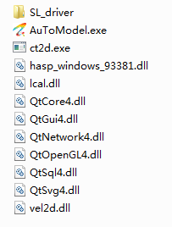

Fig 1.1 files of AutoModel

1.3 Install driver of AutoModel

Double click setup.bat in the directory of /**SL_driver** in Fig 1.1, The following window will appear.

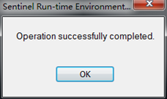

Fig. 1.2 driver installation information window

Select **OK**, then the following window appears,

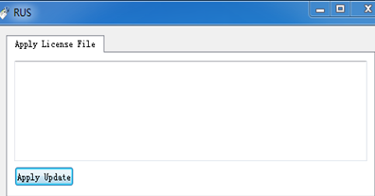

Fig. 1.3 License update information window

Select **Apply Update**, then the following window appears,

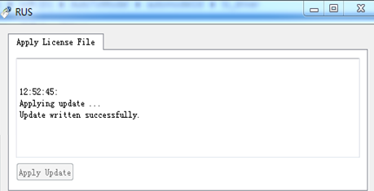

Fig. 1.4 License update information window

Once you installed AutoModel on one computer, you can use is for 90 days.

1. Running AutoModel in batch mode

2.1 Starting AutoModel

Double click AutoModel.exe in Fig. 1.1, the main interface appears.

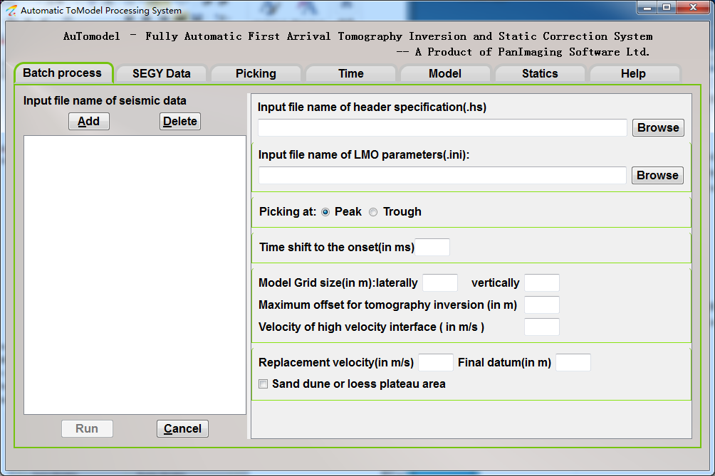

Fig. 2.1 AutoModel main interface

2.2 Define the header file

Select **SEGY data loading** -> **File** -> **Open** from the main interface of Fig 2.1.

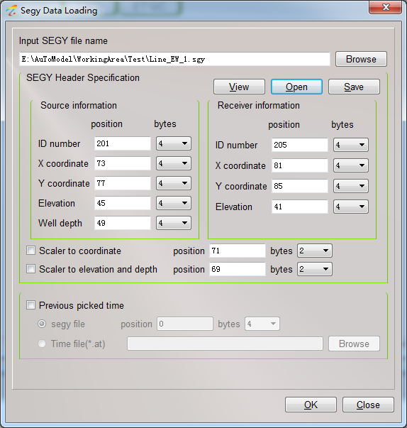

Fig. 2.2 defining SEGY header file window

Input file name of seismic data by clicking on **Browse**, check the information in the header by **View**, and then define the header information, save into .hs file, which will be used later by clicking on **Save** button. Use **Open** to input a header file which has been created.

2.3 Define the LMO parameter file

Input file name on seismic data in SEGY format, and click OK in Fig.2.2 and the data will be displayed in the following window.

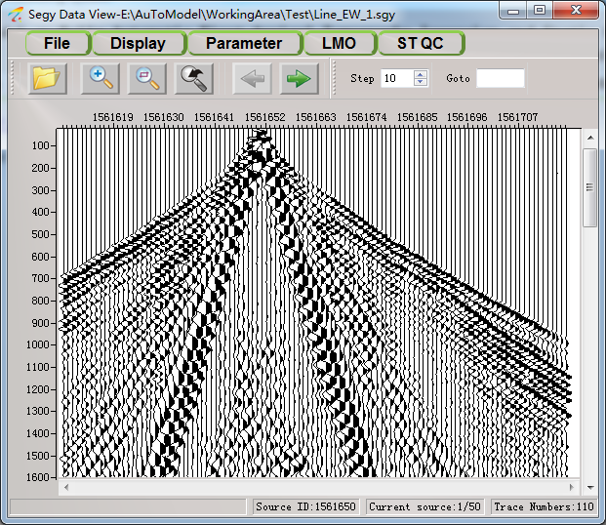

Fig.2.3 Seismic data display window

Selesct **LMO->Show LMO Frame** from fig. 2.3, the default LMO parameter will be displayed like the following window.

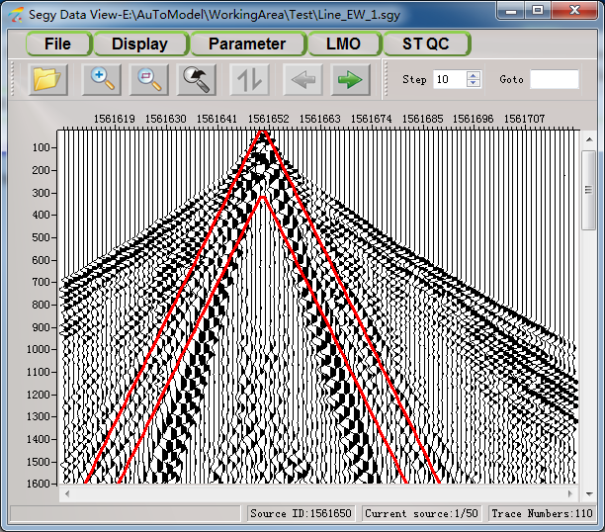

Fig. 2.4 seismic data display window with default LMO parameters

Use left click to change the velocity, put the cursor on the red line and change it by left drag. Check the red box on other shots, be sure it is appropriate for all the shots, like Fig 2.5.

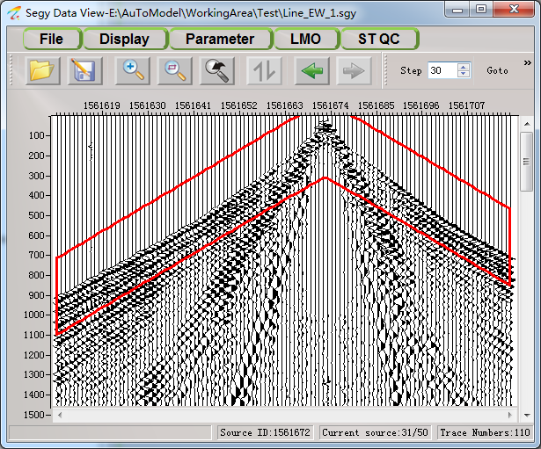

Fig. 2.5 seismic data display window with default appropriate parameters

Select **LMO** -> **LMO setting**, the LMO parameters will appear as:

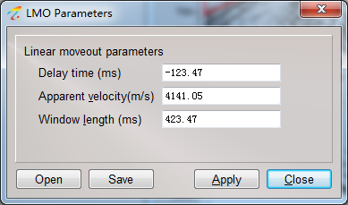

Fig. 2.6 LMO parameters setting window

Save the LMO parameters by selecting **Save**.

2.4 Batch mode process

On the interface of Fig 2.1, input file names of seismic data, header file, LMO parameters file, parameters and click **Run**. It will process in batch mode.

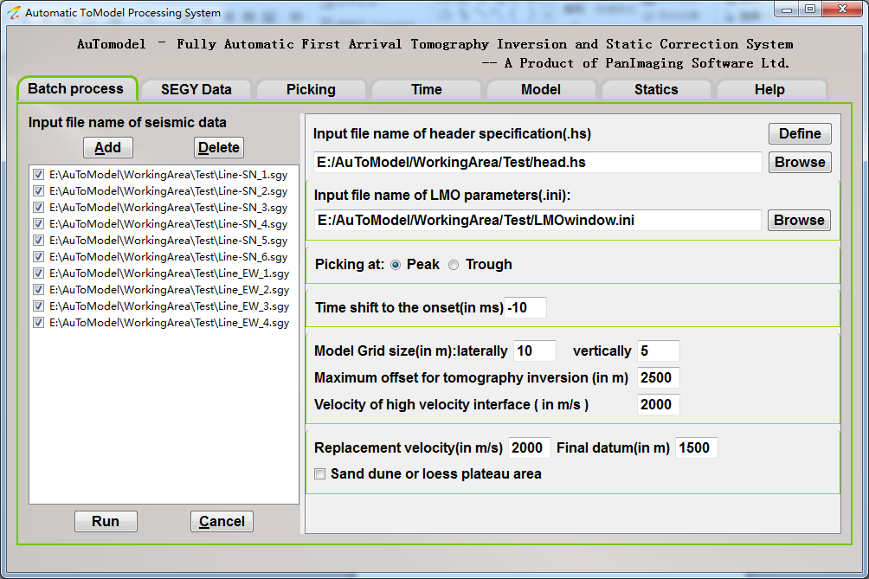

Fig. 2.7 Batch mode process parameters input window

The file names of lines, which have finished inversion, will be displayed in blue color and the process is displayed in the bottom of the windows, like Fig 2.8

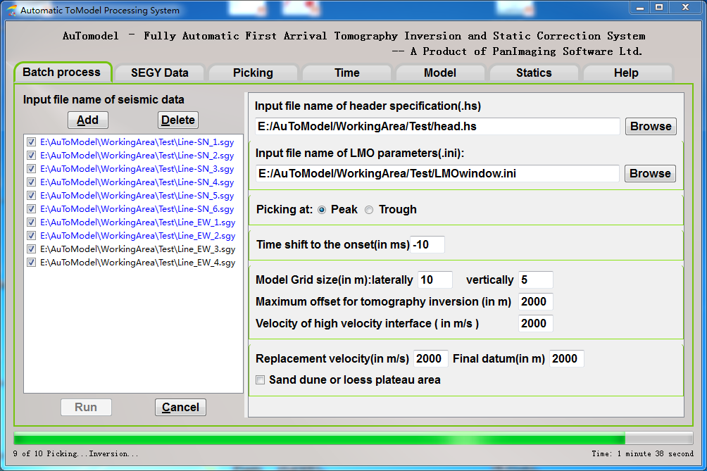

Fig. 2.8 process indicator of batch mode process

2.5 Batch mode process results

Suppose you have 2 lines, after defining the header file and LMO parameter file, you will have the following 4 files.

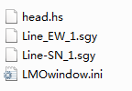

Fig. 2.9 files before batch process

There are will be such files after batch mode process.

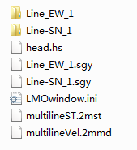

Fig. 2.10 files after batch process

**multilinesST.2mst** and **multilineVel.2mmd** are statics and velocity models for all the lines with real coordinate which can be displayed for QC by selecting **Statics** -> **Statics estimation** -> **File** -> **Open Multiline** and **Model** -> **Velocity model** -> **File** -> **Open Multiline** from the main interface separately.

There is a directory to store all the temporary files and statics result for each line, the directory name is same as the seismic file name as shown in fig. 2.10. The files in each directory are shown in the following window.

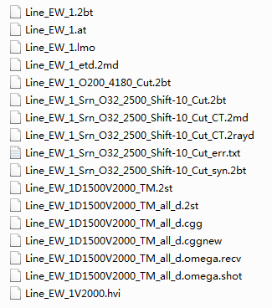

Fig. 2.11 files in the temporary directory

**Line_EW_1.lmo** is the first arrival data after linear moveout correction.

**Line_EW_1.at** is the first arrival travel time with real coordinate.

**Line_EW_1.2bt** is the first arrival travel time with relative coordinate after transformation.

**Line_EW_1_etd.2md** and **Line_EW_1V2000.hv**i are velocity model and high velocity interface for the whole line separately.

**Line_EW_1D1500V2000_TM.2st** is the datum statics.

**Line_EW_1D1500V2000_TM_all_d.2st** is the total statics, that is the datum statics plus with the first arrival residual statics.

**Line_EW_1D1500V2000_TM_all_d.cgg** is the total statics which has been converted into CGG processing system format.

**Line_EW_1D1500V2000_TM_all_d.cggnew** is the total statics which has been converted into CGG processing system new format.

**Line_EW_1D1500V2000_TM_all_d.omega.recv** is the receiver statics for OMEGA processing system.

**Line_EW_1D1500V2000_TM_all_d.omega.shot** is the shot statics for OMEGA processing system.

1. Running AutoModel step by step

If the S/N ratio is very low, the automatic picking, tomography inversion and statics estimation could not give good results in batch mode, you can run AutoModel step by step, more interactive work may be invented, such as interactive first arrival picking, more careful travel time edit for inversion and statics estimation.

3.1 Generating LMO data

Select **Save** button in Fig. 2.5 to output first arrival data for picking after defining LMO parameters.

3.2 First arrivals picking

Select **Picking** -> **File** -> **Open LMO data** from main interface of Fig 2.1 to open the first arrival data, and following window appears.

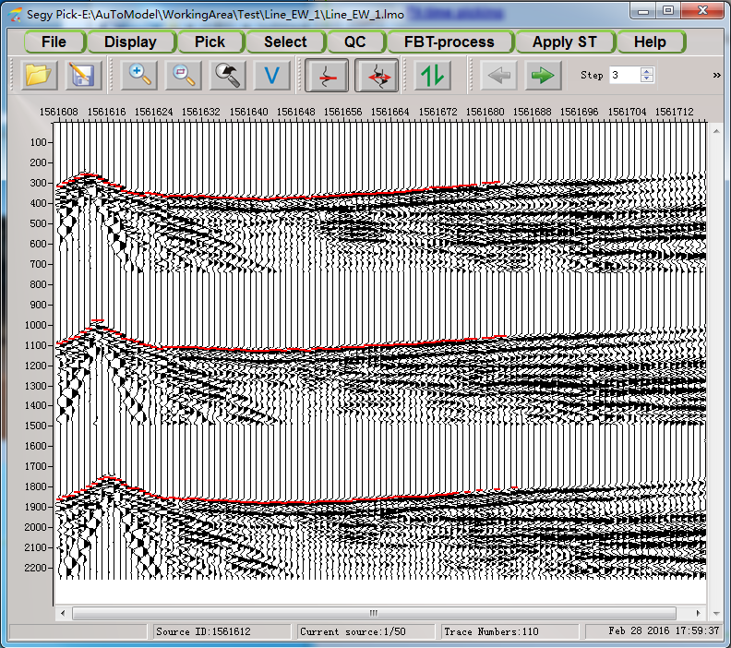

Fig. 3.1 first arrival data display and picking window

Use **Pick** -> **Semi-Auto Picking** to set interactive picking options or **Pick** -> **Automatic picking** in Fig. 3.1. There several shortcut keys for interactive picking, please find it under Help menu. The first arrival data are displayed in FARR. Save the travel time into a file.

3.3 Coordinate transformation

Select **FBT-process** -> coordinate transformation at fig. 3.1, the following dialog appears,

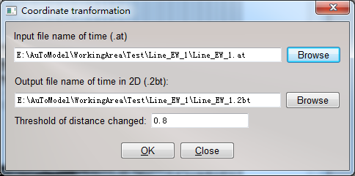

Fig. 3.2 coordinate transformation

Input the file name of first arrivals with suffix of .at and the output file name will be named automatically by ToModel rules. The threshold is used to remove those traces whose S-R distance change too much after transformation.

3.4 First arrivals display and edit

Select **Time** -> **File** -> **open** to load and display the first arrival travel time from the main interface, like the following window.

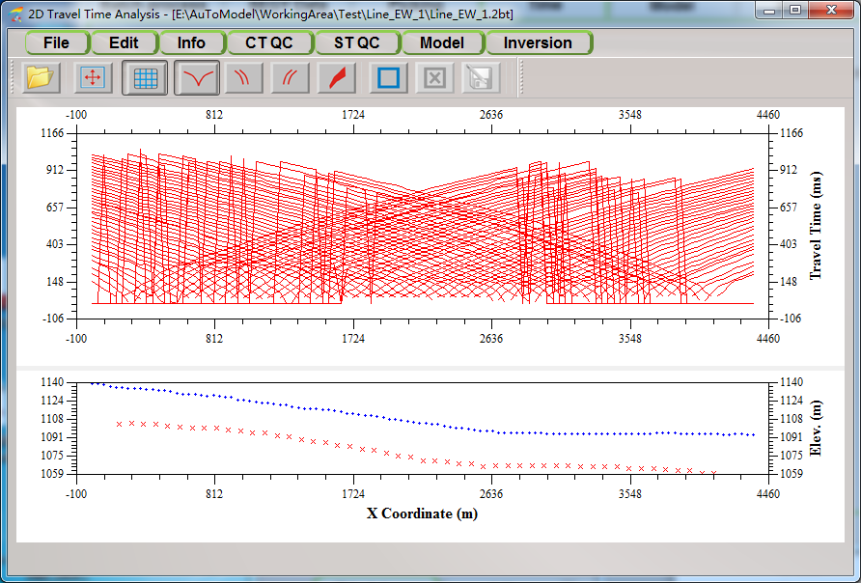

Fig. 3.3 first arrival travel time display window

Normally, we only use traces which are within the range of shots, a value of zero will give to the traces for their travel time if they are not picked, so the zero time should be removed, and also the far offset traces are not good to near surface velocity inversion, use **Edit** -> **Travel Time Edit** to edit the travel time like the following window.

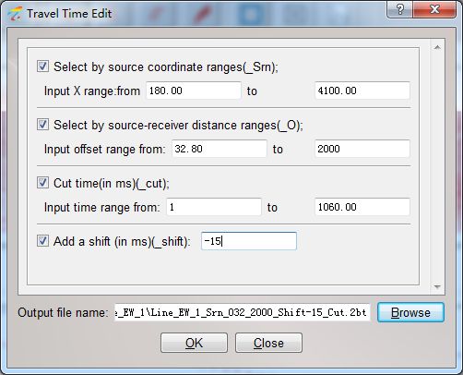

Fig 3.4 first arrival travel time edit window

And also you can select , use left-click to define some control points, right-click to finish to define a polygon, those traces within the polygon will be deleted. Like the following window,

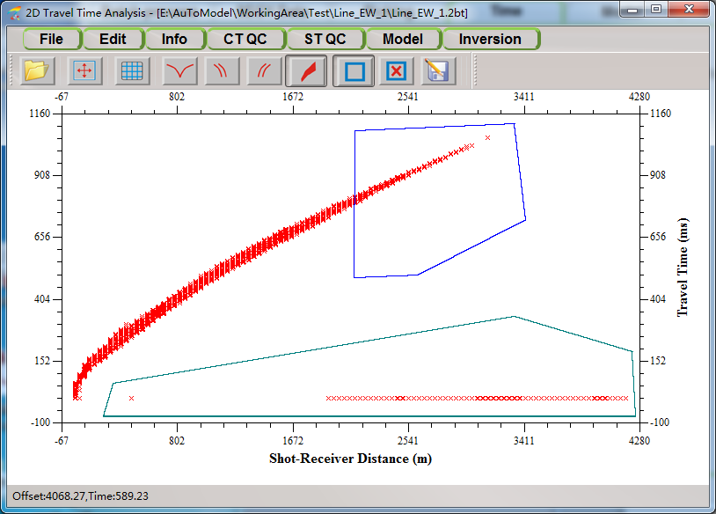

Fig 3.5 interactively edit by defining polygons

3.5 Initial velocity model building

Select **Model** -> **Build model** from Fig. 3.5 to display the travel time in X-T and define the turning point using left-click.

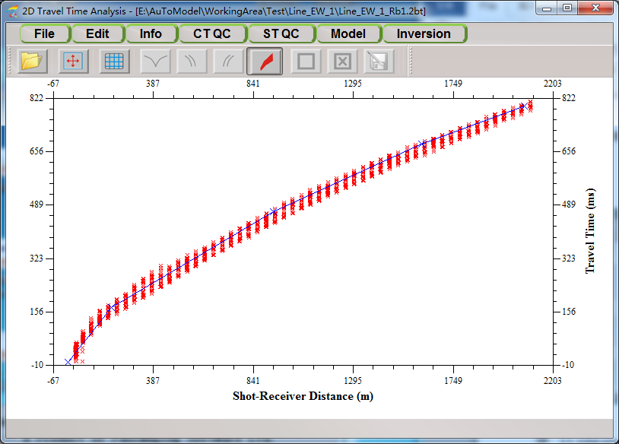

Fig 3.6 defining turning points

After the last control point defined by right-click, the initial velocity information based on delay-time method appears as the following window.

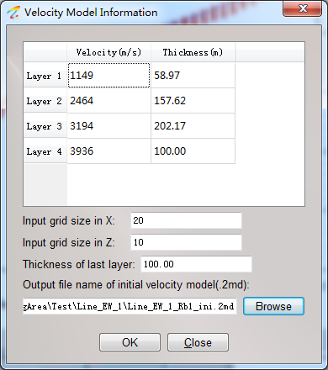

Fig. 3.7 initial velocity model parameters

Select **OK** to build the initial velocity model for inversion.

3.6 First arrival tomography inversion

Select **Inversion** -> **CT Inversion** from Fig. 3.6, the following tomography inversion dialog box window appears,

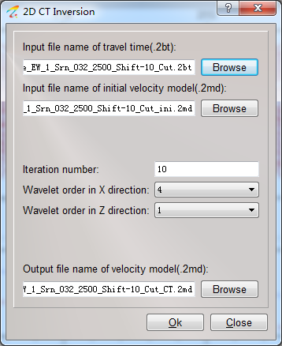

Fig. 3.8 tomography inversion dialog box

3.7 First arrival tomography inversion QC

Select **CT QC** -> **Show Iterative Difference** from Fig. 3.6 to display the iterative difference, like the following window, this curve should be stable and converge.

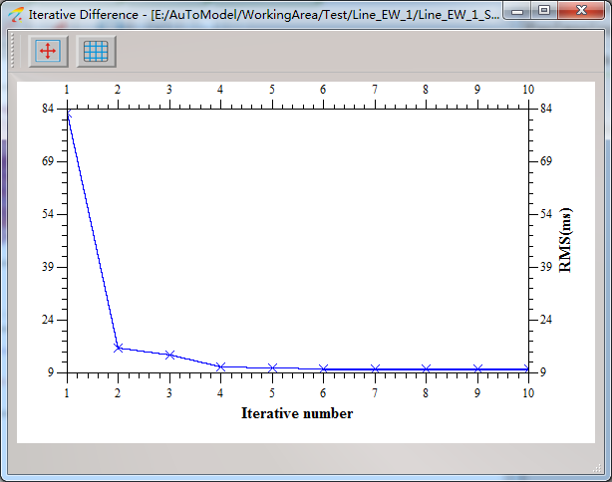

Fig. 3.9 iterative difference curve display

Select **CT QC** -> **Overlay Synthetic Travel Time** to overlap the synthetic travel time like the following window,

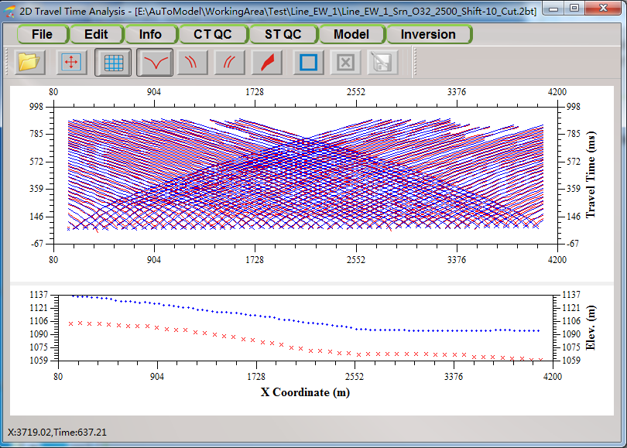

Fig. 3.10 Synthetic travel time display

The red and blue lines are initial and synthetic travel time separately.

Select **Model** -> **Velocity Model** -> **File** -> **Open Ray Density** from the main interface to check whether the depth of initial model is deep enough.

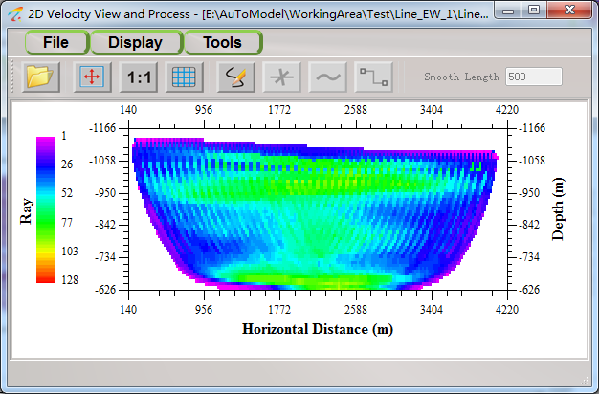

Fig 3.11 Ray density display

If the ray density is like Fig 3.11, that means the initial velocity model is not deep enough, then open the initial model and select **Tools** -> **Model Extend** -> **Downward** to input the thickness to make the initial model deeper.

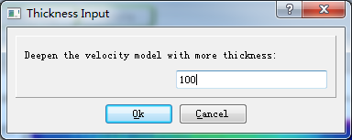

Fig. 3.12 Deepen the initial velocity model

Make the initial velocity model deeper, do inversion again and get the ray density like the following window, there are no rays located in the bottom of the model, that means the thickness is enough.

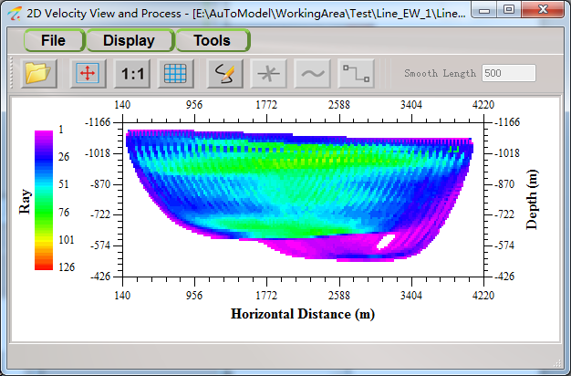

Fig. 3.13 Ray density display

3.8 Extend the velocity model laterally

As the inversion result is only within the range of shots, we need to extend the model to the whole line by selecting **File** -> **Open Velocity** from Fig. 3.13 to display the inversion result like the following window,

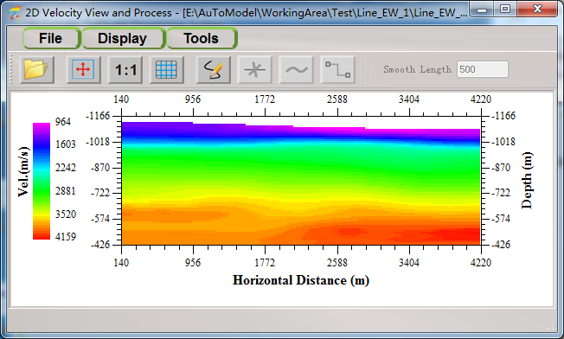

Fig. 3.14 velocity model display window

Select **Tools** -> **Extend** -> **Laterally**, input the travel time file which contains all the shots and receivers, define the reference point and then do extending.

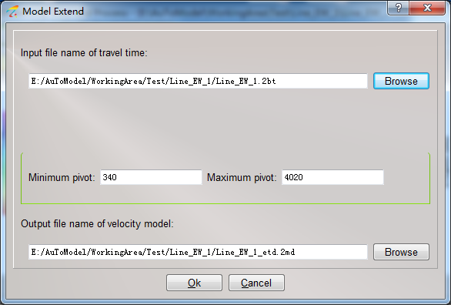

Fig. 3.15 Velocity model extending laterally parameters

3.9 Define high velocity interface

Select **File** -> **Open Velocity** to display the extended velocity model, and then select **Tools** -> **Build Interface** -> **High Velocity Interface**, the following dialog appears,

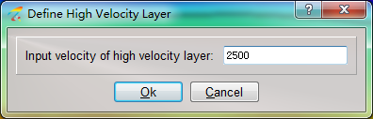

Fig. 3.16 Define high velocity interface dialog

You can use the icons on the interface of Fig 3.14 to modify or smooth the interface to make it more reasonable.

3.10 Calculate datum statics

Select **Statics** from the main interface, the following window appears for statics estimation,

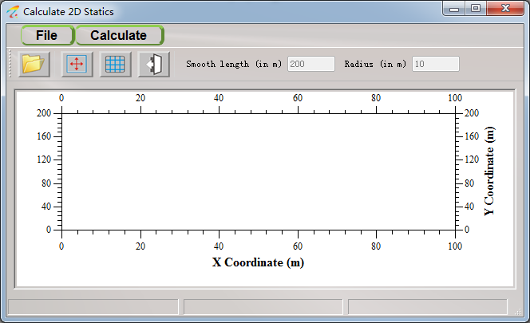

Fig. 3.17 statics estimation window

Select Calculate -> datum statics, then,

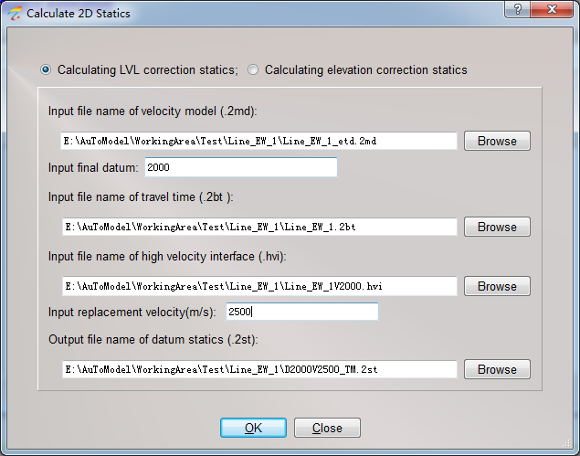

Fig 3.18 Datum statics estimation

The velocity model and travel time file should contain all the shots and receivers for the whole line, and the high velocity interface should match with the velocity model.

3.11 Calculate first arrival residual statics

Select **Calculate** -> **Residual First Arrival Statics** from Fig. 3.17, then,

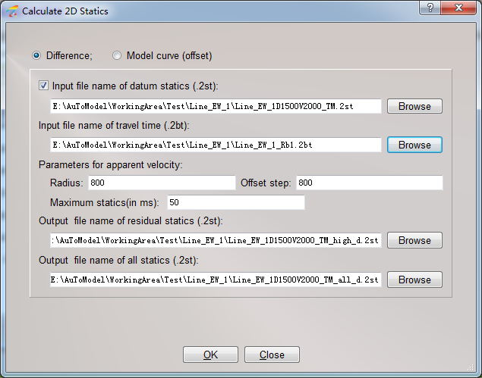

Fig. 3.19 first arrival statics estimation

For sand dune or loess plateau area, the **Model curve** option may be better, for other near surface type, using the **Difference** method. The travel time file should contain the far offset traces.

3.12 Static correction quality control

Select **ST QC** -> **Open** at Fig. 2.5 to input the file name of statics, then using the icon  to apply the statics to the seismic data.

Select **ST QC** -> **Open** at Fig 3.10 to input the file name of statics, the statics will be applied to the travel time and displayed in blue, while the initial travel time is displayed in red, like the following window,

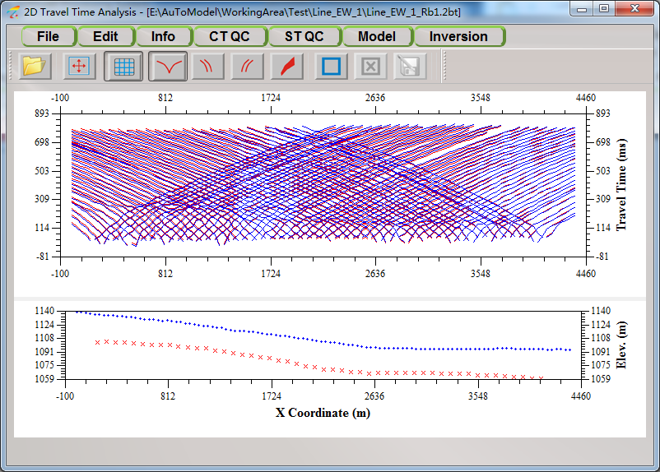

Fig. 3.20 static correction quality control on travel time

Select **ST QC** -> **T-FAR**, for static correction quality control on the T-FAR, which is travel time under surface consistence and linear move out applied, like the following window.

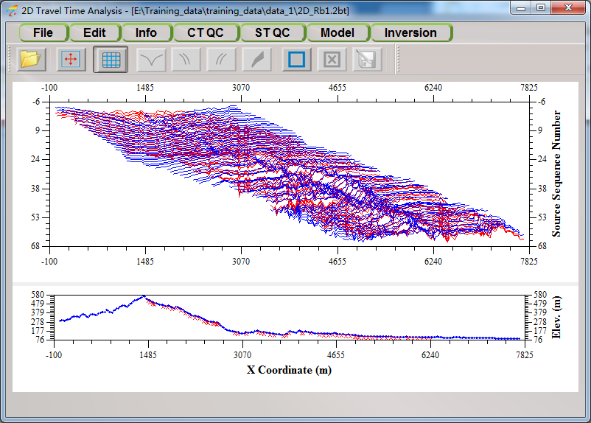

Fig. 3.21 static correction quality control on T-FAR

3.13 Statics Output

Select **File** -> **Output** from Fig. 3.17 to convert the format to the seismic data processing system.

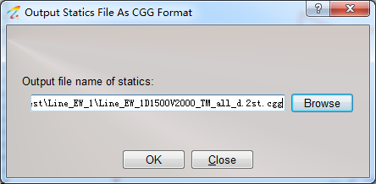

Fig. 3.22 Convert into CGG format

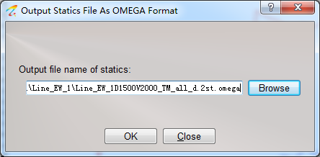

Fig. 3.23 Convert into OMEGA(Promax) format

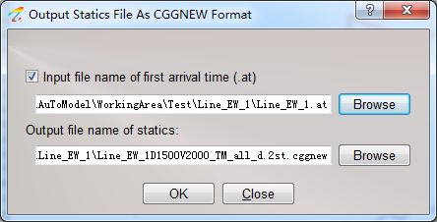

Fig. 3.24 Convert into CGG format with real coordinates

3.14 Display multi-line velocity

After batch mode processing, the velocity of each line will be merged and stored at the same directory named as multilineVel.2mmd, select **File** -> **open multi line** at Fig. 3.14 to display the multi-line velocity, like the following window.

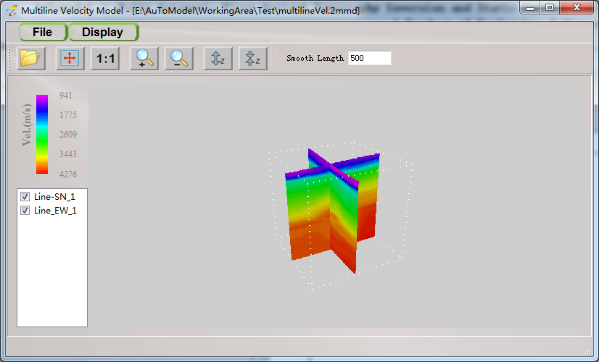

Fig. 3.25 multi-line velocity display

3.15 Display multi-line statics

After batch mode processing, the statics of each line will be merged and stored at the same directory, named as multilineST.2mst, select **File** -> **open multi line** at Fig. 3.17 to display the multi-line statics, like the following window. You can check the match situation at the criss-cross points.

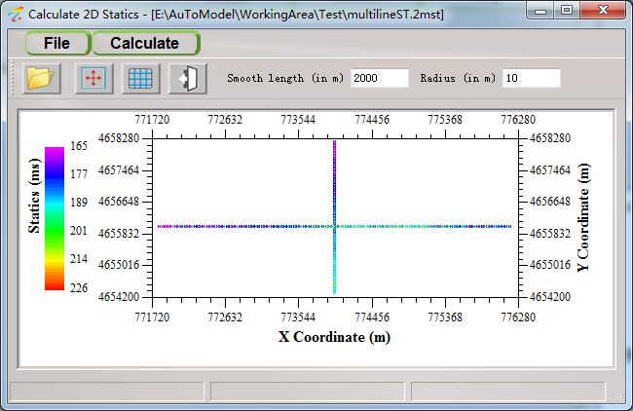

Fig. 3.26 multi-line statics display